# Energy Flow of Ecosystem

The **energy flow** **of ecosystem**means the pathway energy takes to move from one organism to another in an ecosystem. The energy flow of an ecosystem is a fundamental concept of ecological studies. The direction of flow of energy in an ecosystem is **unidirectional**and is typically in the form of food energy that flows from one trophic level to another. It harnesses the energy that cascades through the food chain and food webs. Read this article to learn about **energy flow in ecosystem notes, the laws of thermodynamics that govern it, and the mechanism of energy flow.**

An [ecosystem](https://www.geeksforgeeks.org/what-is-ecosystem/" \t "https://www.geeksforgeeks.org/energy-flow-of-ecosystem/_blank)consists of plants, animals, and their physical environment. It is an area in which all these components interact with each other. An ecosystem has biotic components (living) which include plants, animals, and humans, and it also contains abiotic components (non-living) such as soil, air, water, etc. An ecosystem contains various levels called trophic levels. There is a flow of energy from one trophic level to the other which sustains the ecosystem. In this article, we shall discuss the energy flow in an ecosystem in detail.

## What is Energy Flow of Ecosystem?

*Energy flow in an ecosystem is defined as the movement or transfer of energy from one trophic level to another in an ecosystem. The energy that is passed is in the form of chemical energy.*

Energy flow is the phenomenon that is responsible to sustain life on this planet. All the biotic components in this ecosystem need energy for their survival. If the energy flow in an ecosystem is disturbed, then it leads to ecological imbalance. This energy flow occurs on the Earth through the [biogeochemical cycle](https://www.geeksforgeeks.org/biogeochemical-cycles/" \t "https://www.geeksforgeeks.org/energy-flow-of-ecosystem/_blank).

## Energy Flow of Ecosystem Diagram

The diagram of energy flow of ecosystem is given below:

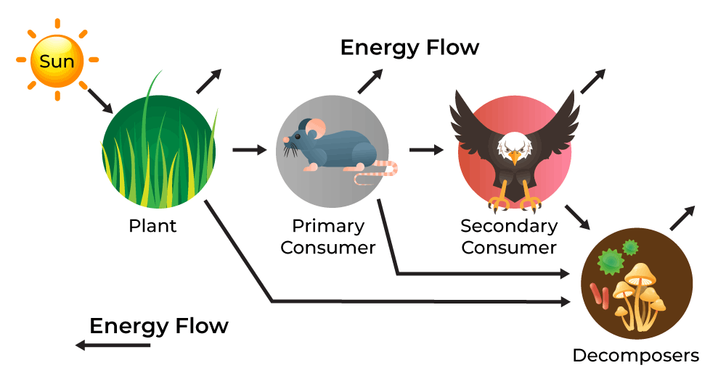

## Laws of Thermodynamics in Ecosystem

The energy flow in an ecosystem is governed by the first two laws of [thermodynamics](https://www.geeksforgeeks.org/thermodynamics/" \t "https://www.geeksforgeeks.org/energy-flow-of-ecosystem/_blank). These two laws are explained as follows;

* **First Law of thermodynamics:** It states that energy can neither be created nor destroyed, but it keeps changing from one form to the other. Similarly in an ecosystem, the main source of energy is the sun, and this energy from the sun is transferred from one level to the other.
* **Second Law of thermodynamics:** It states that when energy transforms from one form to another, some part of it is lost as heat to the surroundings. Thus the energy at one level is never completely transferred to the other.

## What is the Direction of Energy Flow of Energy in an Ecosystem?

The direction of the energy flow in an ecosystem is unidirectional. It flows from the primary source of energy i.e. the sun’s light energy to producers o

hich then transferred to the consumers. The producer uses the solar energy to produce organic food which flows through a series of trophic levels. Each trophic level captures a portion of this energy for its metabolic needs, while the rest is passed to the next level. The flow of energy follows the following pathway;

Solar Energy –> Producer (autotrophs) –> Consumer (herbivores) –> Consumer (carnivores) –> Consumer (higher levels of carnivores)

## Mechanism of Energy Flow in Ecosystem

Animals get energy in two forms: radiant energy and fixed energy. Radiant energy comes from [electromagnetic waves](https://www.geeksforgeeks.org/electromagnetic-waves/" \t "https://www.geeksforgeeks.org/energy-flow-of-ecosystem/_blank), like light. Fixed energy is stored in objects and substances as chemical energy.

Organisms that convert radiant energy to fixed energy are called autotrophs. [Heterotrophs](https://www.geeksforgeeks.org/heterotrophic-nutrition/" \t "https://www.geeksforgeeks.org/energy-flow-of-ecosystem/_blank)get their energy from autotrophs. The sun is the main source of energy in our ecosystem. But less than half of the sun’s energy is used by plants for photosynthesis i.e. 50% of this energy is **photosynthetically active radiation (PAR)**.

Plants convert radiant energy to fixed energy and pass it on to other organisms. When the sun shines on plants, they use it along with carbon dioxide and water to make glucose and oxygen. The oxygen goes into the atmosphere and the glucose stays in the plant. When herbivores eat plants, they get energy from the plant. Some of this energy is lost as heat.

When carnivores eat herbivores, there is again a loss of some energy. We call this the 10% law because only 10% of the energy available at one level is transferred to the next level. The flow of energy in an ecosystem is unidirectional, meaning it only goes in one direction. We can’t transfer energy to a previous level. To understand this, we need to learn about trophic levels and the food chain.

### Trophic Levels

An ecosystem is divided into various levels called trophic levels. Various trophic levels are as follows:

* **First trophic level:**This level is occupied by the **producers**which include the plants.
* **Second trophic level:** It is occupied by the primary consumers that consume plants. For example herbivores such as cows, goats, etc.
* **Third Trophic Level:** This level is occupied by the primary carnivores or secondary consumers such as snakes, frogs, birds, etc.
* **Fourth trophic level:**Large carnivores that are also called tertiary consumers make up this level. Example: Lion, Tiger, Cheetah, etc.

## Food Chain

The [food chain](https://www.geeksforgeeks.org/what-is-food-chain-definition-characteristics-uses-importance/" \t "https://www.geeksforgeeks.org/energy-flow-of-ecosystem/_blank) represents the flow of energy from one level to the other in an ecosystem. It is based on the fact that an organism is consumed by another organism in the ecosystem. In general, the food chain exists only in small [ecosystems](https://www.geeksforgeeks.org/what-is-an-ecosystem-how-do-human-beings-influence-ecology/" \t "https://www.geeksforgeeks.org/energy-flow-of-ecosystem/_blank), and this is replaced by a food web in complex ecosystems.

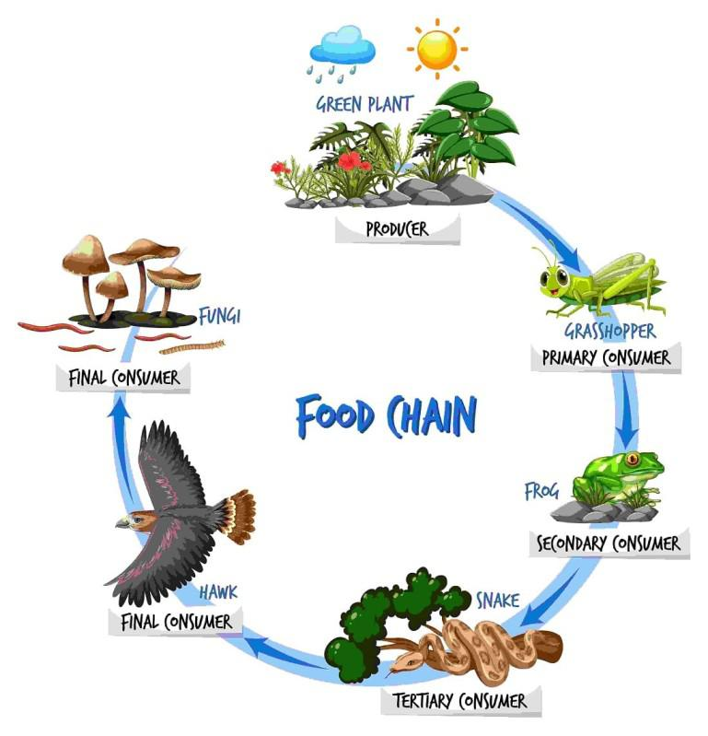

In the above food chain:

1. In the first stage, plants are eaten by herbivores such as grasshoppers.
2. Then herbivores such as deer are consumed by carnivores such as lions, tigers, etc.
3. On the death of carnivores, they are consumed by scavengers such as eagles and vultures.
4. When vultures die, their bodies are broken down by bacteria and fungi to nutrients.
5. These nutrients are again used by the plants for their growth.

## Significance of Energy Flow in Ecosystem

Following are some of the significance of Energy Flow in an Ecosystem;

1. It is vital for all living thing sin ecosystem to survive and function properly.
2. It helps us to understand who eats whom in nature.
3. More the diversity of organisms more stable the ecosystem is.
4. It shows how all creatures in an ecosystem depend on each other and how changes can affect each other.
5. It helps us to see how human action are affecting the ecosystem.
6. Understanding the flow of energy in an ecosystem helps us to devise proper conservation techniques to save the ecosystem.

## Conclusion – Energy Flow of Ecosystem

The energy flow of an ecosystem is essential for ecological balance. Energy flow involves the transfer of energy from one organism to another, primarily through food. This flow is governed by the laws of thermodynamics. It is unidirectional from the sun to producers and then to consumers, sustaining life. Understanding trophic levels and the food chain helps in learning about the process of flow of energy in ecosystem which is crucial for maintaining biodiversity.